Question 1. Kouchaki & Smith (2014) hypothesized that our ability to make accurate, unbiased judgments varies across the day. In particular, our tendency to make biased decisions that benefit ourselves increases across the day, leading to a “morning morality effect” where more biased and possibly unethical decisions are made in the afternoon. One way to test this is to run a study where participants are randomly assigned to either a morning (8am-9am) or afternoon (4pm-5pm) experimental session. In the session, participants make a series of difficult perceptual judgments in which a large number of dots are shown on a computer screen with a horizontal line through the middle. Participants have to judge whether there were more dots above or below the line but critically, they were told that they would be paid 50 cents whenever they indicated that there were more dots above the line and 5 cents when they responded there were more dots below. Because they were paid by their responses, they could make more money by responding ‘above’ even when it was incorrect. To measure how strongly their bias was shown, on 10 critical trials there were just slightly more dots below the line and the number of times these were judged ‘above’ was measured for each participant.

1. What are the two key constructs being studied in this experiment. (6 pts)
2. Which construct is operationally defined as the independent variable? Describe the independent variable. (5 pts)
3. Which construct is operationally defined as the dependent variable? Describe the dependent variable. (5 pts)

Question 1 continued.

1. Here are some hypothetical data that might have come from this study. The scores are based on the number of ‘above’ responses for the 10 critical trials.

|  |  |  |  |
| --- | --- | --- | --- |
| Condition | Mean | SD | SE |
| Morning | 2.7 | 1.19 | 0.28 |
| Afternoon | 4.2 | 1.35 | 0.32 |

|  |  |  |  |  |  |  |  |  |  |
| --- | --- | --- | --- | --- | --- | --- | --- | --- | --- |
|  | Levene's Test for Equality of Variances | |  | | | | | | |
|  | F | Sig. | t | df | Sig. (2-tailed) | Mean Difference | Std. Error Difference | 95% Confidence Interval of the Difference | |
|  |  |  |  |  |  |  |  | Lower | Upper |
| Reported number of solved matrices | .406 | .528 | 3.665 | 34 | 0.001 | 1.5556 | 0.42438 | |  | | --- | | 0.6931 | | 2.41801 |

What type of analysis did the authors use to evaluate the effect of the IV on the DV (be as specific as you can)? Was it reliable (yes/no)? (4 pts)

1. Write out the results statements that describe the data. Include both descriptive and inferential statistics in the standard APA. (6 pts)
2. Give two routine principles of fair and ethical treatment of human subjects and explain how they are related to the design described in this experiment. (5 pts)
3. We have all the circadian rhythm – a “body clock” that tells our bodies when to sleep and regulates many other physiological processes across the day. Identify an alternate hypothesis that might also account for the data observed and indicate if this is an internal validity threat. (4 pts)

Question 2. Definitions.

Fill in the blanks with the appropriate terms (3 points each, 30 total):

____________________ A university-wide committee that reviews proposed research to safeguard the safety and rights of human participants.

____________________ The technique of assigning participants to treatments so that each participant has an equal chance of being assigned to each treatment condition.

____________________ The subsection of the Methods section where you indicate who was in the study.

____________________ A technique for controlling subject variables (e.g., age) by systematically distributing participants based on that variable.

____________________ A technique for controlling an extraneous variable (e.g. time of day) so that it does not vary consistently with the independent variable.

____________________ A threat to internal validity that only occurs for within-subject experimental designs.

____________________ This is when the effect of one independent variable changes across the levels of another independent variable; can only be detected in factorial designs.

____________________ The hypothesis that there is no relationship between the variables, that is, the different levels of the independent variable do not affect the scores on the dependent variable.

____________________ An extraneous variable that varies with the independent variable and creates an internal validity threat.

____________________ An error made by failing to reject the null hypothesis even though it is really false; failing to detect a treatment effect.

Question 3. In Gino & Mogilner (2014), researchers examined the relationship between time, money, and dishonesty. They found that, when people are focused on money, they behave in self-interested ways, making them more likely to engage in dishonest behaviors. By contrast, when people are reminded of time, they tend to self-reflective and less likely to cheat. They showed that thoughts of time or money can be primed by asking participants to help search through lists of songs that have lyrics pertaining to how people feel or think about a particular topic: either “money” or “time.”

Maria the morality researcher set out to extend this idea to examine the effect of manipulating motivation to perform well on the time/money effect. To measure dishonest behavior, she had participants solving logic problems on a computer screen but with a second screen was placed off to the side of the room. Participants were warned that the answers would appear on this second screen for the benefit of the experimenter sitting in the room with them, but were asked to please not look at this other screen. The experimenter in the room counted the number of times they glanced over at the answer screen as a measure of how dishonest the participants were.

Before doing the logic problems, participants completed the song-list search procedure to prime them for thoughts of either time or money. To affect motivation, Maria also told half of the participants that the game was an intelligence test and for the other half of the participants, the game was described as a personality test.

She predicted that if priming time decreases cheating by making people reflect on who they are, cheating behavior in the personality condition would not differ between participants primed with money and those primed with time. However, participants who were told that the game was a test of intelligence would show greater cheating after primed with money but less cheating after primed with time. (35 points total)

1. What type of experimental design is this study? (4 pts)
2. What are the independent variable(s) here? What are their levels? (6 pts)
3. Describe the three results/hypotheses that are embedded in the analysis of this kind of experimental design. (8 pts)
4. Because the test problems are based on logic, Maria is concerned that the major of the undergraduates in the study might be a problem. Specifically, that math majors will find the problems too easy and never be remotely tempted to cheat. How could she handle this? (6 pts)
5. What potential validity threat about the dependent variable is related to the idea of using a ‘double blind’ procedure. How might you improve Maria’s study to make sure this isn’t a problem? (6 pts)
6. The participants to be recruited for this study were planned to be a mix of students who receive course credit for Introduction to Psychology and students who are paid $10 to participate in the study. How might this create a reliability problem based on the specifics of the experimental design? (5 pts)

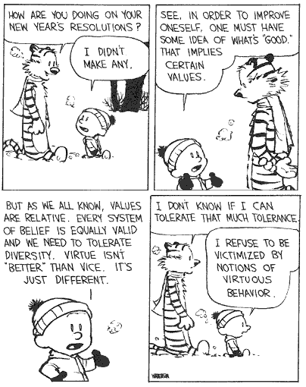

Individual differences can pose problems for research on morality…